We have taught the students all of these strategies. If your child can look at the question and do it quickly in their head, that’s great! However, all students have to understand how to find the sums. Your child may have another strategy that works for them and that’s fine. Our goal is for all students to do the mental thinking as outlined below, but some students may need to draw a number line, or base 10 blocks, or use the hundred chart for support at this time

Here are some ways that show how to add a 2 digit number to a 1 digit number.

Example 1: Add the ones and then add on the tens

59 + 7 = ?
9 + 7 = 16 (add the 2 digits in the ones place)
50 + 16 = 66 (then add the 5 tens, which is 50 and the 16 ones together)

Example 2: Make a friendly number

59 + 7 = ?
60 + 7 = 67 (make the 59 a 60 because multiples of 10 are easier to add, then add the 7)
67 – 1 = 66 (since you added 1 to the 59 to make it a 60, you have to remember to take it off)

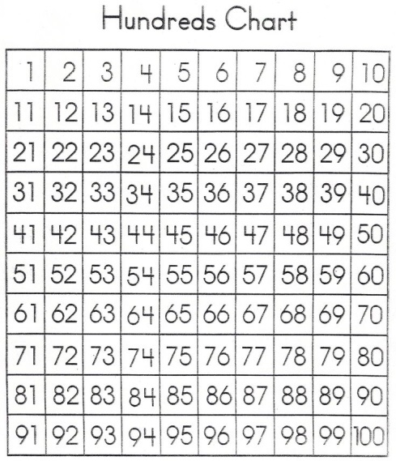
Example 3: Count on

59 + 7 = ?
59 + 1 = 60 (add 1 to get to 60)
60 + 6 = 66 (then add the other 6)

Please complete the following addition problems and show your thinking. (As in the examples above.)

- 76 + 3 = 2. 45 + 8 = 3. 72 + 7 =

4. 39 + 6 = 5. 65 + 9 = 6. 29 + 5 =

7. 84 + 9 = 8. 37 + 6 = 9. 55 + 8 =

